Our system contains purchases and sales documents. However, it does not support multiple warehouses, but this scheme is often used, especially if we purchase goods in very large quantities and cannot store all the goods directly in the store.
- Select and create a suitable Warehouses object, add the Warehouse attribute to the purchase invoice and sales invoice documents.
- Add a new Warehouse subsystem. Put the new Warehouses object from p.1 to it.
- Add the Warehouse attribute to PurchaseInvoice and SalesInvoice documents (don’t forget to put a field on its forms).
- Develop the InventoryTransfer configuration object to reflect operations of moving goods between warehouses. Add it to the Warehouse subsystem. The document must contain attributes WarehouseSender and WarehouseRecipient, tabular section “Products” with Product and Quantity attributes/columns.
- Create a document form for the new document and arrange form elements so that there are 2 columns in the document header and 2 lines with attributes on the left: string 1) number and date; string 2) Warehouse sender. On the right there is one line, opposite the warehouse sender with the Warehouse receiver field.
Hint: you can use label decoration without any title as a spacing before/after/between form elements. If the height of a decoration is not suitable (it needs to be made larger/smaller vertically) you can change the font size in the Font property of a field.
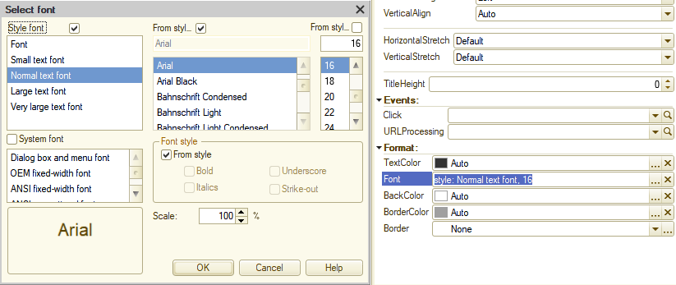
- Add a “Pick” button to the document form that works the same way as in Purchase invoice and Sales invoice documents.
- Add a “Fill in by the remaining goods” button to the document form (command bar of a the Products tabular section). This button should run the following algorithm:
- If the sending warehouse is not filled in the document, display to the user the message “it is necessary to fill in the sending warehouse” and interrupt execution
- If there is at least one row in the product table, display the question “The tabular section will be cleared. Do you want to continue?” with buttons "Yes" and "No"
- If a user clicks "No", abort further processing. If the user clicks "Yes", clear the tabular section and fill it with the remaining goods on the document date at the sending warehouse. Remaining goods must be obtained using the formula: the sum of all posted (Posted = True) purchase documents up to document date - the sum of all posted sales documents up to document date. You should get this data with a query using temp tables and a query batch. As a result, you should have a query batch in which there is a temporary table Purchases, a temporary table Sales and a table that selects all purchases - (minus) all sales (if any).

Let's look at how to use user interaction using a question. To display a question, the ShowQueryBox method is used; read about this method yourself in the syntax assistant.
CallbackDescription = New CallbackDescription("FillInByTheRemainingGoodsAnswer", ThisObject);
If Object.Products.Count() > 0 Then
ShowQueryBox(CallbackDescription, "The tabular section will be cleared. Do you want to continue?", QuestionDialogMode.YesNo);
Else
RunCallback(CallbackDescription, DialogReturnCode.Yes);
EndIf;

The method is asynchronous, which means that code execution is not interrupted when the method is called, but continues until the end of the call. When a response is received from the user, the export method specified in the NotifyDescriptionOnCompletion parameter (it’s the object with the CallbackDescription type) will be called, where the result of the user's response will be passed (one of the buttons that the question box contained, for example, "Yes", "No", "Cancel").
Let's look at the above code line by line. On the first line, we create a new object of type CallbackDescription, which is required to be passed to the ShowQueryBox method. The first parameter of this object is the name of the export procedure that will be called after receiving a response from the user. The second parameter points to our configuration module in which the export procedure is located. This means that the response processing procedure may be located in a different module than the module in which the question was created (we will not spend time now explaining why this might be useful). In the next line I check if there are rows in the table section with the Count() method. If there are rows, I ask the user using the ShowQueryBox method whether he agrees to clear the tabular section. To the ShowQueryBox method, I pass the callback description, the text of the question that will be shown to the user, as well as the buttons available to the user as an answer.
&AtClient
Procedure FillInByTheRemainingGoodsAnswer(Result, AdditionalParameters) Export

If Result = DialogReturnCode.Yes Then
FillInByTheRemainingGoodsAtServer();
EndIf;

EndProcedure
This is what the procedure looks like, which will be called after the user responds. The Result parameter contains the user's response, this is the DialogReturnCode system enumeration, with possible options Abort, Cancel, Ignore, No, OK, Retry, Timeout, Yes. I check if the answer is Yes and call the server method to fill out the tabular section. If the answer is different, then a user refused to fill out the tabular section with the loss of changes and no action is required.
Let's take a look at the Else branch of condition for the presence of rows in the tabular section. The RunCallback method immediately calls the procedure specified in the Callback description, the second parameter of this method will be passed to the procedure as the Result. You will have to implement the algorithm for filling the tabular section with data yourself.
So, our application allows users to display information about purchases and sales. But the fact of purchase/sale does not always indicate the fact of payment; in settlements with other companies, payment occurs both before receiving the goods and after. Sometimes one payment covers several purchases/sales transactions. Let's create the PaymentExpense and PaymentReceipt configuration objects to reflect the fact of payment from our company to the supplier and from the buyer to our company. In addition to these objects, we will also need to create objects to store banks and bank accounts.
In addition to these objects, we will also need to create objects to store banks and bank accounts.
- Add Banks object to store the list of banks. Object should contain attributes NationalCode, Country, City, Address, CorrAccount.
- Add BankAccounts object to store the list of bank accounts. Bank account can’t exist without link to a bank. Object should also contain attributes AccountNumber, OpeningDate, CloseDate.
- Add a new Funds subsystem, include Banks and BankAccounts objects to it, don’t forget to set a picture for this subsystem.
- Create a configuration object PaymentExpense to reflect the payment transaction from our company's account. The object must contain the attributes BankAccount, Counterparty, DocumentAmount and the PaymentDetails tabular section with the attributes Document (DocumentRef.PurchaseInvoice), Amount. The tabular section indicates all the documents for which payment is made. Add this object to the Funds subsystem. The document can be generated based on the Purchase invoice document. In this case, the Counterparty attribute should be filled with the Vendor from the Purchase invoice, one line should be added to the tabular section, where Document = Purchase invoice, Amount = Purchase invoice Amount.
- Create a configuration object PaymentReceipt to reflect the transaction of receipt of funds to our company's account as payment for goods and/or services. The object contains the same attributes and tabular section as the "PaymentExpense" object, only the Document attribute of the PaymentDetails tabular section has the DocumentRef.SalesInvoice type. The tabular section indicates all the documents for which payment is made. Add this object to the Funds subsystem. The document can be generated based on the Sales invoice document. In this case, the Counterparty attribute should be filled with the Customer from the Sales invoice, one line should be added to the tabular section, where Document = Sales invoice, Amount = Sales invoice Amount.
- Add to both documents a “fill in by balance” button, when clicked, the tabular part is filled in according to the following algorithm:
- If the counterparty is not filled, display a message to the user that filling is possible only by vendor (for expenses)/client (for receipts) and stop executing the code.
- If there are already rows in the tabular section, warn a user that the tabular section will be cleared and ask if he wants to continue. If a user agrees, it is necessary to find all posted Purchase Invoice (for expenses) or Sales Invoice (for receipts) documents that are not yet presented in the posted payment documents and add them to the tabular section along with their amounts.
Training tasks
- Write a query text that selects Sales order documents in which the amount of services is not more than 1000.
- Write a query text that selects Sales order documents in which the amount of services is more than 5000 and the amount of goods is 0.
- Write several separate queries using a temporary table manager, the final query should select products whose purchase amount and sales amount are greater than 0. Only the posted Purchase Order and Sales Order documents should be taken into account.
- Write a query text that selects products for which no more than a week has passed between the last purchase and the last sale.
- Write a query text that selects purchases and sales of goods in the context of documents for a certain period (between StartDate and EndDate). The query must contain 4 fields:
- Product
- Document (Purchase invoice or Sales invoice)
- Quantity (total for document)
Amount (total for document)
Also, the result of such query must be two-level - at the first level the quantity and amount are the totals for the product, that is, the report structure looks like the picture below. Sort data by a product’s description.
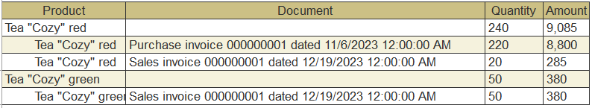
- Write a query text for the Products catalog, consisting of two fields
- Description
- Details
In the Details field, you should display the string “This is a group” if the product is a catalog’s group and “This is not a group” if the product is a catalog’ item.
- Write a query text to the Products catalog that will select all products that are NOT included in groups (at any nesting level) whose description contains the word “water” (anywhere in the description, not necessarily at the beginning or end).

